# **Data Type**

In DL PEL-HIL, we recommend using three data types: boolean, uint16, and single.

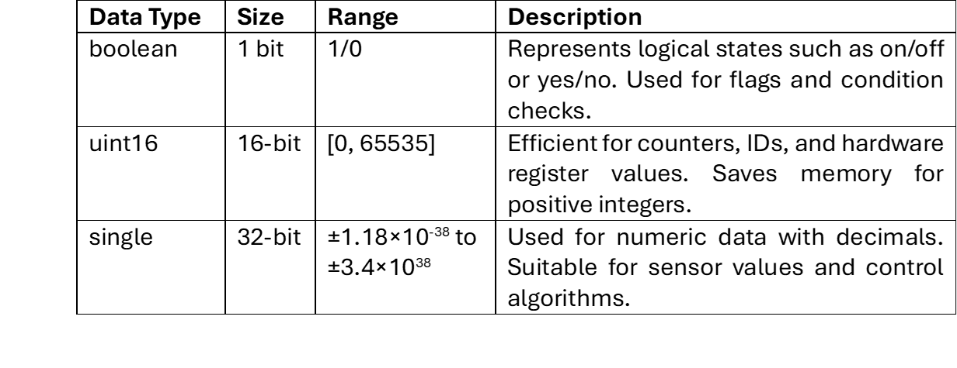

Notes:

💡 *Some DL built-in blocks specify a data type and therefore require matching input/output signals for consistency.*

💡 *Use single type for precision; use boolean and uint16 for speed and memory efficiency.*

# **Data Serialization & Parsing**

**Single** type is unified in DL PEL-HIL RX/TX; multiple **booleans** and **uint16s** are serialized into singles before TX.

After RX, **Single** in DL PEL-HIL RX/TX is parsed back into **booleans** and **uint16s** to restore data.

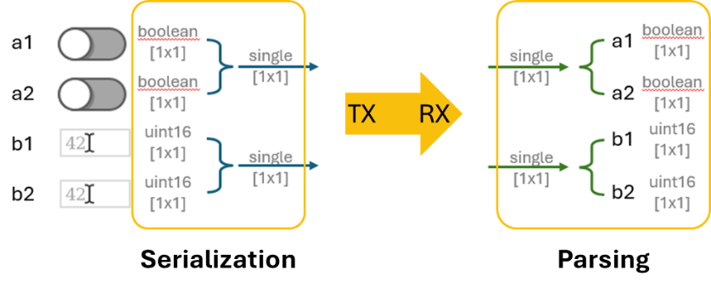

*Serialization and Parsing Process*

*Blocks for Serialization and Parsing*

# **Signal Dimensions**

In the context of communication, a signal can take various forms:

* a single data element,
* a combination of multiple single-element signals, or
* a set of signals that each include historical (past) data.

As a starting point, let’s first explore the different dimensions that signals can have.



In DL PEL-HIL, we use

* **Scalar** to represent a single data element,
* **Row Vector** to represent a combination of multiple single-element signals,
* **Matrix** to represent a set of signals that each include historical (past) data.

# **Row Vector Construction & Extraction**

Use mux to combine same-type **scalar** elements into a **row vector**.

Use demux to extract **scalar** elements from a **row vector**.

To observe the waveform of a row vector with an oscilloscope, process the input as **columns as channels**.

# **Matrix Construction & Extraction**

Matrix creation occurs only before target model’s TX: **no. of columns** defined by mux, **no. of rows** defined by target TX’s ‘no. of data in a frame’.

Column extraction occurs only after host model’s RX, done by split matrix.

